Title (circle as appropriate) | Mr Mrs Miss Ms Mx Dr Master
First Name(s)
Surname
NHS number
Date of birth
Gender (please circle) | Male Female Non-Binary Other (please specify):
Address- including postcode

Preferred contact numbers
(Must be UK number)
Email address
Town and country of birth
(please state both)
Last Known Address
(If applicable)
Name of previous GP Practice
Are you new to the UK?  Interpreter required? | Yes / No Date of entry to the UK:  If yes, state first language:
Please indicate your ethnicity below:
British or mixed British (9i0) |  |  |  | Indian or British Indian (9i7)
Irish (9i1) |  |  |  | Pakistani or British Pakistani (9i8)
White Irish (9i10) |  |  |  | Bangladeshi or British Bangladesh (9i9)
Other White Background (9i2) |  |  |  | Other Asian Background (9iA)
White and Black Caribbean (9i3) |  |  |  | Caribbean (9iB)
White and Black African (9i4) |  |  |  | African (9iC)
White and Asian (9i5) |  |  |  | Other Black Background (9iD)
Other Mixed Background (9i6) |  |  |  | Chinese (9iE)
Other (9iF) Please state: |  |  |  | Ethnic category not stated (9iG)

Next of Kin Information
Are they registered with us? | Yes / No
Next of kin name

Relationship to you

Contact number (must be a UK number)

Is this person your emergency contact? | Yes/ No
Can your next of kin discuss your medical record with us? | Yes / No
Is this person a registered carer for you? | Yes/ No
Online Access
We can provide you with access to book GP appointments, order repeat prescriptions, view your medical records and test results online.
Would you like an online account? Yes / No
(Your registration instructions will be emailed to you, please ask at reception for more details)
Contact Preferences
Would you like to be contacted by text message? Yes / No
Would you like to be contacted by email? Yes / No
If you have given us permission to contact you by phone, SMS or email we will use your details to remind you of appointments, book reviews and follow-up tests. Information about health campaigns such as Flu, NHS Health Checks or other patient education events that might be important to you will also be sent, along with any significant practice changes. You will also be able to give feedback on the quality of our services.
Nominated Pharmacy
Please specify the pharmacy you would like any future medication to be sent to below:
_________________________________________________________________
If you are on repeat medication you will need to book a medication review with a GP or our practice pharmacist before you can order this.

(Staff use only)
Photo ID Verification details (type of ID and number if applicable):
_________________________________________________________________
Staff member checked: Date registered:
Health questionnaire
Please answer these questions as accurately as you can. If you do not know the answer, leave it blank.
Height: __________ Weight: __________
Are you a military veteran? Yes / No
Have you ever smoked? Yes / No
Do you smoke now? Yes / No If yes, how many per day? __________
If you are an ex-smoker, when did you stop? __________
Do you drink Alcohol? Yes / No If so, How many units per week? ________
Please list any allergies you have:

Please list any medical conditions or disabilities you have:

Have any of your blood relatives have suffered from the following:
Hypertension (high blood pressure), heart attack, stroke, diabetes, breast cancer, ovarian cancer?
Please state which member of your family, what did they/do they suffer from and what age were they diagnosed.

Carer Details
Do you help to look after someone who is ill, frail or disabled? Yes / No

Who do you look after (e.g. partner, child, relative or friend)?

_____________________________________________________________
Do they live with you? Yes / No

Are they registered at this practice? Yes / No

Carers Leeds offers a confidential support and information service to carers. If you would like further information, please ask one of our receptionists for their leaflet.
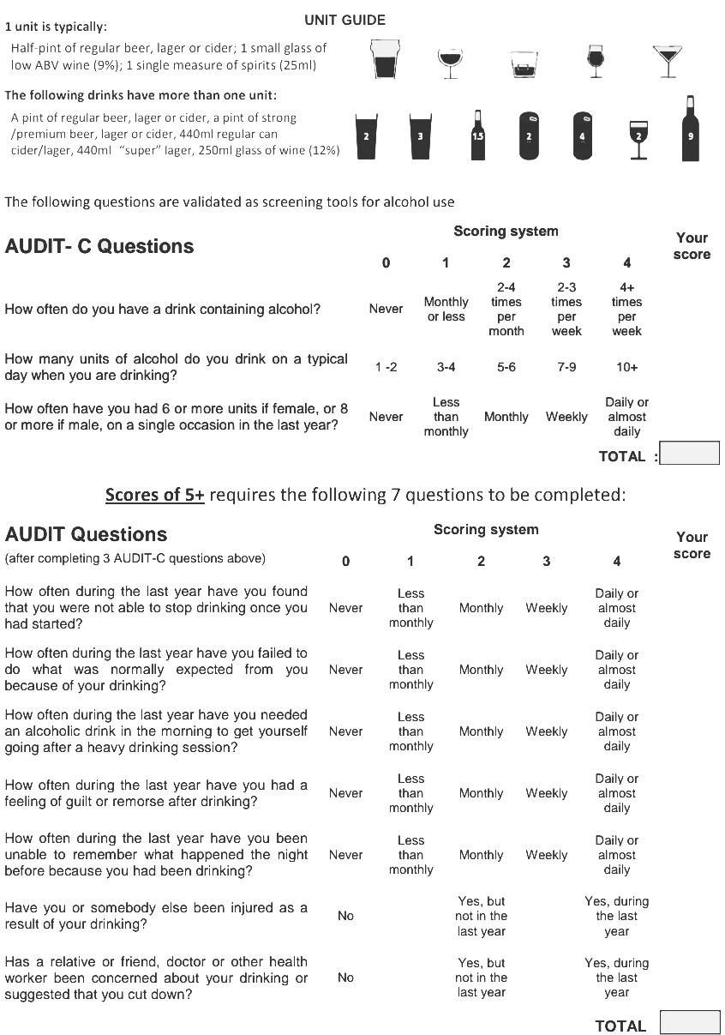
Alcohol screening
Thank you for taking the time to fill out this form.

